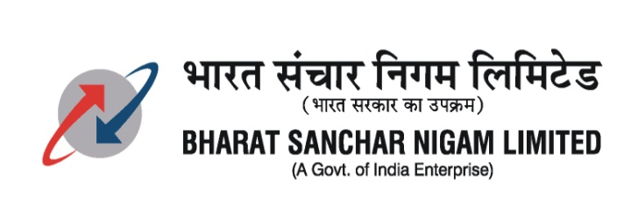
OFFICE OF THE GENERAL MANAGER
TELECOM DISTRICTBALASORE -756001

NOTICE INVITING TENDER

NIT No: N-29 /12-13/3 Dated at Balasore 15.11.2012.

Sealed tenders are invited by the GMTD, BSNL Balasore for laying of PLB/HDPE Pipes and pulling of OFC for the following zones in Balasore Telecom District from bonafide and licensed contractors having minimum experience in executing PLB/HDPE pipe laying & OFC pulling works/underground cable laying work/5pr UG cable work for Rs.20,00,000/- (Rupees twenty lakh) only during the last 3 financial years i.e. 2009-10, 2010-11, 2011-12 in BSNL/MTNL/Central Govt./Other PSUs.

Tender documents will be obtained from the Sub-Divisional Engineer (Planning), O/o GMTD, BSNL Balasore between 10:30 hrs. to 13:30 hrs. on any working day from 19.11.2012 to 10.12.2012 on production of D/D of Rs.1050/- (Rs.1000/- + 5%) only, in favour of AO (Cash), O/o GMTD, BSNL, Balasore payable at any Nationalized Bank at Balasore towards cost of tender paper (Non-refundable) along with the experience certificate issued by an officer not below the rank of DGM/TDM of BSNL or equivalent cadre.

Area of contract:

Sl No | Details of area | Zone | Approx quantum of work | Approx estimated cost in Rs. | EMD in  Rs.
01 | PLB pipe laying & OFC pulling work under Chandbali SDCA. | 1 | 32 Kms | 20,16,000/- | 40,320/-
02 | PLB pipe laying & OFC pulling work under Bhadrak SDCA. | 2 | 26 Kms | 16,38,000/- | 32,760/-
03 | PLB pipe laying & OFC pulling work under Balasore SDCA | 3 | 30 Kms | 18,90,000/- | 37,800/-
04 | PLB pipe laying & OFC pulling work under SDOT, Basta | 4 | 26 Kms | 16,38,000/- | 32,760/-
05 | PLB pipe laying & OFC pulling work under Soro SDCA | 5 | 30 Kms | 18,90,000/- | 37,800/-
06 | PLB pipe laying & OFC pulling work under SDOT, Jaleswar | 6 | 26 Kms | 16,38,000/- | 32,760/-

Last date of sale of tender paper | 10.12.2012 up to 13.30 hrs.
Last date of receipt of tender form | 11.12.2012 up to 13.30 hrs.
Time and date of opening tender | 11.12.2012 at 15.30 hrs. in the Conference Hall, O/o the GMTD, BSNL, Balasore

The above Tender is also available at the Balasore page of website: www.orissa.bsnl.co.in for detail information.

1. Submission of Tender: - The Tender papers completed in all respect shall be addressed to the AGM (HR & Admn), O/o the GMTD, BSNL Balasore and will be dropped into the Tender box available in his chamber or to be received by Regd. Post on or before 13.30 hrs. of 11.12.2012. The bid received late will be returned unopened. The envelope shall be super scribed as “Tender for OFC construction works in Balasore Telecom District for Zone---”. The tender received after the due date and time will be summarily rejected.

2. The quantum of HDPE/PLB pipe laying and OFC pulling may be increased or decreased as per actual requirement without any change in the rates or terms and conditions specified in the tender.

3. The experience in PLB pipe laying & OFC pulling work/underground cable laying work/5pr UG cable work for Rs.20,00,000/- (Rupees twenty lakhs) only during the last 3 financial years issued by an officer not below the rank of DGM/TDM of BSNL/MTNL/Central Govt./Other PSUs.

4. The tender paper can be downloaded from the concerned website. But while dropping, a D.D. of Rs.1050/- (non refundable) in favour of the AO (Cash), O/o the GMTD, BSNL, Balasore towards the cost of the tender paper must be enclosed inside the envelope containing the Bid Security; otherwise the tender will not be taken into consideration. The GMTD BSNL, Balasore will also not be responsible for any alteration/omission in the contents of the tender document either while uploading on the website or otherwise.

5. Each contractor shall be eligible to apply for maximum of three zones for which separate tender papers have to be purchased for each zone. More than three zones will not be allowed to any individual bidder.

6. The Tender which is not accompanied by the requisite Bid Security shall summarily be rejected. The GMTD BSNL, Balasore reserves the right to reject any or all Tenders without assigning any reason what so ever. In case the last date of dropping falls on a holiday, the next working day will be treated as last date.

Sd/- General Manager Telecom District,
BSNL, Balasore-756001

